TRACHEOSTOMY DISLODGEMENT

SUMMARY

Tracheostomy is commonly performed in the intensive care unit setting. The most common associated complications are bleeding (first 24 hours), tube dislodgement (first 7-10 days), and tracheal stenosis (> 10 days). Tracheostomy tube dislodgement is associated with multiple complications, the most feared of which is airway loss with resultant anoxic brain injury and possible death. Appropriate care and monitoring in the first 10 days post-tracheostomy reduce the incidence of tracheostomy tube dislodgement.

RECOMMENDATIONS

Level 1

None

Level 2

None

Level 3
  - Tracheostomy tube length should be carefully considered based upon patient neck size and depth of trachea
  - Tracheostomy tubes should be secured to the skin with sutures for the first seven (7) days post-insertion to help prevent dislodgement
  - Tracheostomy tubes should be changed by the performing surgeon when necessary in the first ten (10) days post-insertion
  - Tracheostomy tube cuff pressure should be monitored and maintained at 20-30 cm H₂O
  - When tracheostomy tube cuff pressure is checked, downward pressure should be applied to the tube to prevent upward dislodgement of the tracheostomy tube
  - All hospitals should have a “Difficult Airway Plan” for managing acute airway loss

INTRODUCTION
Tracheostomy is commonly performed to facilitate a safe airway in patients with airway obstruction or malignancy, copious pulmonary secretions, ventilator dependence, or chronic respiratory insufficiency (1-3). Early appropriate tracheostomy has been demonstrated to reduce hospital length of stay and patient cost of care (4). While tracheo-innominate fistula has historically been considered the “dreaded complication” of tracheostomy, low-pressure, high-volume tracheostomy cuffs and improved tracheostomy positioning have significantly reduced the incidence of this devastating event. Post-tracheostomy complications are generally divided into (with the most common occurrence) intraoperative (bleeding), early (tracheostomy dislodgement), and late (tracheal stenosis) with incidences of 1.4%, 5.6%, and 7.1% respectively (5,6). Tracheostomy tube dislodgement is associated with multiple potential complications including loss of airway, subcutaneous emphysema, pneumothorax, pseudotract formation, stomal stenosis, sternoclavicular osteomyelitis, and trachea-innominate fistula. The most devastating complication of tube dislodgement is anoxic brain injury and patient death.
LITERATURE REVIEW
A multi-institutional study by Halum et al. found a 0.8% accidental decannulation rate within the first postoperative week and a 1.2% accidental decannulation rate after one week (6). Multiple factors are associated with an increased risk for tracheostomy tube dislodgement. These include:

- Early post-operative period (first 7 days)
- Morbid obesity
- Short or thick neck
- Enlarged thyroid gland / goiter
- Prior radiation or surgery of the neck
- Patient movement or turning
- Frequent coughing
- Connection to ventilator tubing
- Inadequately secured tracheostomy tubes
- Inadequate tracheostomy tube length

Of these risk factors, early post-operative period (due to inadequate maturation of the tracheostomy tract), ventilator tubing position, inadequately secured tubes, and inadequate tracheostomy tube length are the most amenable to intervention to reduce patient harm. One tracheostomy tube size does not fit all patients. The appropriate size of tube must be determined at the time of tracheostomy based upon the patient’s neck size and tracheal depth (Appendix 2). This is especially true for morbidly obese patients and those with large neck circumferences where external landmarks may not accurately reflect the depth of the patient’s trachea. Studies have suggested that pre-procedure computed tomography or intraprocedural ultrasound guidance (to determine the distance from the patient’s skin to mid-trachea) can help to determine the appropriate length of tracheostomy tube required (7-9).

All tracheostomy patients should be carefully monitored for signs of tracheostomy dislodgement until a mature tract has formed. This typically takes 7-10 days but can take longer in critically ill or immunosuppressed patients with delayed wound healing. Warning signs for tracheostomy dislodgement include the following:

- Hypoxia
- Respiratory distress
- Increased work of breathing
- Noisy breathing
- Subcutaneous emphysema
- Visible cuff in the tracheal stoma
- Absent breath sounds on auscultation
- Inability to pass a suction catheter
- Patient speaking around an inflated tracheostomy tube cuff
- Tracheostomy tube flange elevated above skin level
- Loss of end-tidal carbon dioxide (ETCO₂) measurements
- Loss of exhaled tidal volume

All patients with possible tracheostomy tube dislodgement should be rapidly evaluated in a methodical fashion to determine whether the tracheostomy tube is, in fact, within the trachea or not. Patients identified to have tube dislodgement should receive rapid restoration of a secure and patent airway to decrease the risk for patient harm. Rubin et al. performed a quality improvement analysis of tracheostomy-related complications (5). They proposed the following checklist for first tracheostomy tube change. Many of these key strategies are shared by the Emergency Tracheostomy Management algorithm (Appendix 1):
- Perform by the service which performed the original surgical procedure
- Perform between 6 AM and 6 PM
- Practitioner should be competent in tracheostomy tube exchange / management of airway loss
- Light source available
- Shoulder roll utilized
- Rigid and flexible suction available
- Appropriately sized new tracheostomy tube
- Clinical team alerted (nurse, ICU team, respiratory therapist)

Surgeons who place tracheostomy tubes should be aware of the tubes available in their operating room and ensure that the initial tracheostomy tube is appropriately sized for the patient’s anatomy. Morbidly obese patients and those with a larger neck circumference will have a higher likelihood of requiring a tube with a longer proximal length (Appendix 2). The use of a tracheal hook to insert the tracheostomy tube should be avoided where possible as this may lead to a false sense of security in identifying a tube of adequate length. Over-inflation of the tracheostomy cuff should be avoided as this can obscure an inadequate seal and malpositioning of the tracheostomy tube. An inadequate seal with appropriate cuff volumes at the time of insertion suggests that a tube of inappropriate size has been placed. This should be corrected during the initial insertion rather than placing the patient at increased risk of tracheostomy tube dislodgement. It is essential that the tracheostomy tube flange be flat against the skin with the cuff inflated. Elevation of the flange above the skin suggests that the inflated cuff may actually be outside the trachea (Figure 1). The use of stay sutures to secure tracheostomy tubes is controversial. Evidence shows that they can decrease the risk of perioperative bleeding complications but that they do not decrease the risk of premature tube dislodgement (5,6).

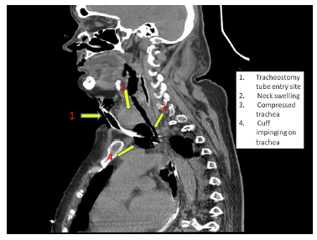
Figure 1: CT of the neck demonstrating a dislodged tracheostomy tube (due to inadequate proximal length) with the inflated cuff outside the trachea (9)

From a nursing and respiratory therapist standpoint, the practice of placing multiple tracheostomy sponges beneath the tube flange should be avoided. This places upward pressure on the tracheostomy tube cuff and increases the risk of cuff migration outside of the tracheotomy, especially when the cuff is deflated for any reason. A single gauze sponge beneath the flange is appropriate. Care should be taken to use the tubing holder on the bedside ventilator to avoid pulling on the tracheostomy tube as this can also lead to premature dislodgement. During transport with either a mechanical ventilator or an Ambu-bag, close attention should be paid to avoid tube dislodgement.

Tracheostomy tube cuff pressures should be monitored daily and maintained at 20-30 cm H₂O throughout the patient’s duration of mechanical ventilation. Acceptable devices for objectively monitoring cuff pressures include the Posey Cufflator™ or disposable Pressure Easy™. Do not subjectively “feel” the pilot balloon and add air using a syringe without checking the cuff pressure using one of these devices.

Tracheostomy / endotracheal cuff pressure should be checked immediately post-intubation or after placement of a tracheostomy tube, upon arrival from the operating room, before and after patient transport, and at least once per shift (and as needed). Cuff over-inflation can result in tracheo-esophageal fistula, tracheal necrosis, tracheal stenosis, and tracheomalacia. Cuff under-inflation can result in microaspiration of secretions and loss of tidal volume during mechanical ventilation. When checking such pressures, however, it is important that downward pressure on the tracheostomy tube be applied whenever the cuff is deflated. Failure to do so may allow the tube to migrate upward with further malpositioning position when the cuff is inflated as it may be outside the trachea. Inflation of the cuff while it is in the tracheotomy can result in devastating tracheal rupture and severe injury that can be difficult to repair.

Step-by-step Procedure for Checking Tracheostomy Cuff Pressure:
- Before use, check cufflator integrity by placing a finger over the silver port and squeezing the bulb. Pressure should hold at 120 cm H₂O for 2-3 seconds.
- Assess the patient’s tracheostomy tube:
  - Is the tracheostomy tube secured appropriately?
  - Is the tracheostomy tube flange flat against the neck with proper skin protection (no stacked gauze)?
  - Is the ventilator or aerosol tubing supported properly to prevent pulling on the patient’s tracheostomy tube?
  - If the patient is mechanically ventilated, is the end-tidal carbon dioxide (ETCO₂) waveform and value present on the bedside monitor?
- Attach the silver port to the tracheostomy tube pilot balloon.
- Adjust the pressure to a safe range of 20-30 cm H₂O.
  - Use the bulb to add air and the red button to release air
  - Use the lowest amount of air needed to achieve a seal
  - Always apply downward pressure on the tracheostomy tube while adjusting the cuff pressure to prevent upward dislodgement of the tube out of the trachea.
  - Document the adjusted cuff pressure; compare to previously documented cuff pressures to look for trends. Make a note in the patient’s record if significant air needed to be added.
- Clean the cufflator with an appropriate disinfectant.
- If using a disposable cuff monitoring device, ensure that the reading is in the 20-30 cm H₂O range at all times. Add air with a syringe via the port as needed and then recap it.

Troubleshooting
- If leakage of air occurs around the cuff at 30 cm H₂O, evaluate the tracheostomy tube for dislodgement and/or proper size. Notify the patient’s physician of the increased cuff pressure requirement.
  - Has the cuff pressure requirement been gradually or suddenly increasing?
  - Have the patient’s ETCO₂ and ventilator volumes changed?
  - Evaluate the patient’s chest radiograph for proper tracheostomy tube placement
- If cuff pressures decrease after adding air, evaluate whether the cuff or pilot balloon / valve is leaking. If the pilot balloon or valve is leaking, use a repair kit. If the tracheostomy cuff is leaking, the tube will need to be replaced under a physician’s order.

Difficult Airway Plan
All hospitals should have a predefined plan for how they will respond to the patient with a difficult airway such as tracheostomy tube dislodgement, premature extubation, or airway compromise due to neck surgery resulting in edema or hematoma (anterior cervical fusions, thyroidectomy / parathyroidectomy, carotid endarterectomy, head & neck oncologic surgery). The scope of this plan will vary according to the resources available. A tertiary referral center may create a defined Difficult Airway Response Team (DART) consisting of an in-house critical care intensivist, trauma surgeon, anesthesiologist, and senior respiratory therapist who are available 24/7/365 to respond to difficult airways (Appendix 3) (10,11). A community hospital may only have an emergency medicine physician and respiratory therapist available in the hospital around the clock. The key is to define the individual hospital’s “difficult airway plan” proactively, identifying the manpower and equipment resources that are available and educating all team members of their responsibilities should a difficult airway occur. Just as all hospitals have a universally-known nomenclature for announcing critical events (“Code Blue” for cardiac arrest, “Code Red” for fire, etc…), there should be a clear terminology in the hospital for a difficult airway so that all team members understand the urgency of the situation and that an “all hands on deck” response is warranted.

APPENDIX 1

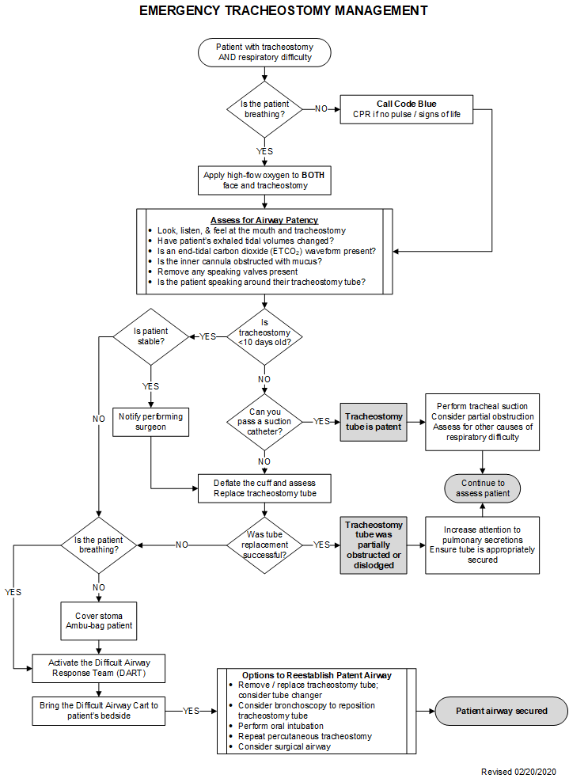
APPENDIX 2

TRACHEOSTOMY TUBE LENGTHS

All tracheostomy tubes are not created equal. Whenever a tracheostomy tube is inserted or replaced, consideration should be given to the depth of the patient’s trachea and a tube of sufficient length utilized. A tracheostomy tube that is too short for the patient’s anatomy places them at risk of premature dislodgement and potential airway loss.

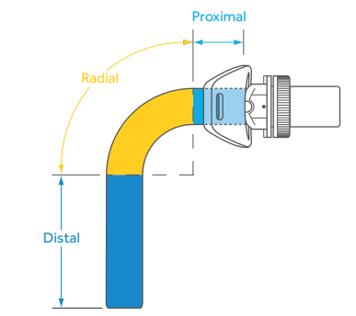

The following are the dimensions of tracheostomy tubes commonly utilized at Orlando Health.
The dimensions of other brands of tubes can generally be determined from
their packaging on the manufacturer’s website.

Brand | Description | Size | Product Code | Proximal Length | Radial Length | Distal Length | Total Length
Shiley | Percutaneous | 6 | 6PERC |  |  |  | 74mm
Shiley | Percutaneous | 8 | 8PERC |  |  |  | 79mm
Shiley | Standard, disposable | 4 | 4DFEN |  |  |  | 62mm
Shiley | Standard, disposable | 6 | 6DFEN |  |  |  | 74mm
Shiley | Standard, disposable | 8 | 8DFEN |  |  |  | 79mm
Shiley | Cuffed, fenestrated | 4 | 4FEN |  |  |  | 65mm
Shiley | Cuffed, fenestrated | 6 | 6FEN |  |  |  | 75mm
Shiley | Cuffed, fenestrated | 8 | 8FEN |  |  |  | 81mm
Shiley | Cuffless, disposable | 4 | 4DCFS |  |  |  | 62mm
Shiley | Cuffless, disposable | 6 | 6DCFS |  |  |  | 74mm
Shiley | Cuffless, disposable | 8 | 8DCFS |  |  |  | 79mm
Shiley | Cuffless, fenestrated, disposable | 4 | 4DCFN |  |  |  | 62mm
Shiley | Cuffless, fenestrated, disposable | 6 | 6DCFN |  |  |  | 74mm
Shiley | Cuffless, fenestrated, disposable | 8 | 8DCFN |  |  |  | 79mm
Shiley | Extended length (XLT) Proximal | 6.0 | 60XLTCP | 23mm | 38mm | 34mm | 95mm
Shiley | Extended length (XLT) Proximal | 7.0 | 70XLTCP | 27mm | 39mm | 34mm | 100mm
Shiley | Extended length (XLT) Proximal | 8.0 | 80XLTCP | 30mm | 40mm | 35mm | 105mm
Shiley | Extended length (XLT) Distal | 6.0 | 60XLTCD | 8mm | 38mm | 49mm | 95mm
Shiley | Extended length (XLT) Distal | 7.0 | 70XLTCD | 12mm | 39mm | 49mm | 100mm
Shiley | Extended length (XLT) Distal | 8.0 | 80XLTCD | 15mm | 40mm | 50mm | 105mm
Bivona | Foam cuff | 6.0 | 670160 |  |  |  | 70mm
Bivona | Foam cuff | 7.0 | 670170 |  |  |  | 80mm
Bivona | Foam cuff | 8.0 | 670180 |  |  |  | 88mm
Bivona | Foam cuff | 9.0 | 670190 |  |  |  | 98mm

APPENDIX 3

DIFFICULT AIRWAY RESPONSE TEAM (DART)

The purpose of the Difficult Airway Response Team (DART) is to rapidly provide appropriate personnel and equipment for the management of airway emergencies throughout the hospital.

A difficult airway is defined as a clinical situation in which a conventionally trained clinician experiences difficulty with mask ventilation, tracheal intubation, or both. The DART provides for immediate, multidisciplinary airway expertise to facilitate a safe and rapid airway for the patient.

The DART consists of:
- Trauma attending on call
- Intensivist on call
- Anesthesiologist on call
- Critical Care fellow / resident on call
- Rapid Response Team (RRT) - nurse and respiratory therapist
- Pharmacy

Clinical indications for activation of DART include:
- History of failed or difficult intubation
- Known history of severe tracheal stenosis
- Significant bleeding from nose or mouth
- Recent tracheostomy or other surgical airway (<10 days)
- Recent neck surgery
- Post-surgical bleeding into the neck
- Inability to open the mouth
- Severe swelling around the mouth and/or neck
- Subcutaneous extravasation of fluids into the neck
- Severe subcutaneous emphysema of the neck
- Significant acromegaly
- Rheumatoid arthritis
- Kyphoscoliosis
- Presence of tracheal stents

Activation of the DART
When a difficult airway is identified, call the hospital operator and request the DART team, providing the patient’s room number. The DART will be paged and respond to the patient’s room with Pharmacy delivering rapid sequence intubation medications to the bedside. The respiratory therapist will obtain the “Difficult Airway Cart” (pre-positioned at one of four sites throughout the hospital) and bring it to the patient’s bedside. The cart contains a specific list of advanced airway management equipment:

- Laryngoscopes with MAC, Miller blades
- Assorted endotracheal tubes
- Endotracheal tube stylets
- Oral airways/ endoscopic bite blocks
- Assorted laryngeal mask airways (LMA)
- Intubating stylet
- Endotracheal tube changers
- Assorted tracheostomy tubes
- Percutaneous tracheostomy kit
- Cricothyroidotomy tray
- Surgical instruments / assorted sutures
- Scalpels
- 14F retrograde intubation kit
- Suction catheters / canister/regulator
- Bronchoscopes with monitor
- Pulse oximeter / capnograph
- Assorted syringes
- Sterile gowns / gloves / caps / masks
- Silicone spray
- Chlorhexidine applicators
- Surgical lubricant

REFERENCES
- Delaney A, Bagshaw SM, Nalos M. Percutaneous dilatational tracheostomy versus surgical tracheostomy in critically ill patients: a systematic review and meta-analysis. Crit Care 2006; 10:R55.
- Mehta AB, Syeda SN, Bajpayee L, Cooke CR, Walkey AJ, Wiener RS. Trends in tracheostomy for mechanically ventilated patients in the United States, 1993–2012. Am J Respir Crit Care Med 2015; 192(4):446–454.
- Cheung NH, Napolitano LM. Tracheostomy: epidemiology, indications, timing, technique, and outcomes. Respir Care 2014; 59(6):895–919.
- Herritt B, Chaudhuri D, Thavorn K, Kubelik D, Kyeremanteng K. Early vs. late tracheostomy in intensive care settings: Impact on ICU and hospital costs. J Crit Care 2018; 44:285-288.
- Rubin SJ, Saunders SS, Kuperstock J, Gadaleta D, Burke P, et al. Quality improvement in tracheostomy care: A multidisciplinary approach to standardizing tracheostomy care to reduce complications. Am J Otolaryngol 2019 (In press).
- Halum SL, Ting JY, Plowman EK, et al. A multi-institutional analysis of tracheotomy complications. Laryngoscope 2012; 122(1):38–45.
- Alansari M, Alotair H, Al Aseri Z, Elhoseny MA. Use of ultrasound guidance to improve the safety
of percutaneous dilatational tracheostomy: A literature review. Critical Care 2015; 19:229.
- Guinot PG, Zogheib E, Petiot S, Marienne JP, Guerin AM, et al. Ultrasound-guided percutaneous tracheostomy in critically ill obese patients. Critical Care 2012; 16:R40.
- Sodhi K. Anticipated Difficult Tracheostomy: Should CT Scan Be a Pre-Requisite. J Emerg Intern Med 2017; Vol 1. No.2:14.
- Mark LJ, Herzer KR, Cover R, Pandian V, Bhatti NI, et al. Difficult Airway Response Team: A novel quality improvement program for managing hospital-wide airway emergencies. Anesthesia and Analgesia 2015; 121:127-139.
- Rassekh CH, Zhao J, Martin ND, Chalian AA, Atkins JH. Tracheostomy complications as a trigger for an airway rapid response: analysis and quality improvement considerations. Otolaryngology-Head and Neck Surgery 2015; 153:921-926.

Surgical Critical Care Evidence-Based Medicine Guidelines Committee

Author: Michael L. Cheatham, MD, FACS, FCCM; Jennifer Brown, RRT
Editor: Michael L. Cheatham, MD, FACS, FCCM
Last revision date: 02/20/2020

Please direct any questions or concerns to: webmaster@surgicalcriticalcare.net

